Egyptian Poetry

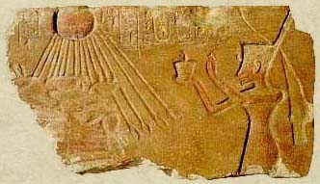
Religious Poetry

God is a Master Craftsman
God is a master craftsman;
yet none can draw the lines of his Person.
Fair features first came into being
in the hushed dark where he mused alone;
He forged his own figure there,
hammered his likeness out of himself--
All powerful one (yet kindly,
whose heart would lie open to men).
He mingled his heavenly god-seed
with the inmost parts of his being.
Planting his image there
in the unknown depths of his mystery.
He cared, and the sacred form
took shape and contour, splendid at birth!
God, skilled in the intricate ways of the craftsman,
first fashioned Himself to perfection.
How Splendid You Ferry the Skyways
How splendid you ferry the skyways,
Horus of the Twin Horizons,
The needs of each new day
firm in your timeless pattern,
Who fashion the years,
weave months into order--
Days, night, and the very hours
move to the very gait of your striding.
Refreshed by your diurnal shining, you quicken,
bright above yesterday,
Making the zone of night sparkle
although you belong to the light,
Sole one awake there
--sleep is for mortals,
Who go to rest grateful:
your eyes oversee.
And theirs by the millions you open
when your face new-rises, beautiful;
Not a bypath escapes your affection
during your season on earth.
Stepping swift over stars,
riding the lightning flash,
You circle the earth in an instant,
with a god's ease crossing heaven,
Treading dark paths of the underworld,
yet, sun on each roadway,
You deign to walk daily with men.
The faces of all are upturned to you,
As mankind and gods
alike lift their morningsong:
"Lord of the daybreak,
Welcome!"
When Being Began Back in Days of the Genesis
When Being began back in days of the genesis;
it was Amun appeared first of all,
unknown his mode of inflowing;
There was no god before him,
nor was there other god with him there
when he uttered himself into visible form;
There was no mother to him, that she might have borne his name,
there was no father to father the one
who first spoke the word, "I Am!"
Who fashioned the seed of him all on his own,
sacred first cause, whose birth lay in mystery,
who crafted and carved his own splendor--
He is God the Creator, self-created, the Holy;
all other gods came after;
with Himself he began the world.

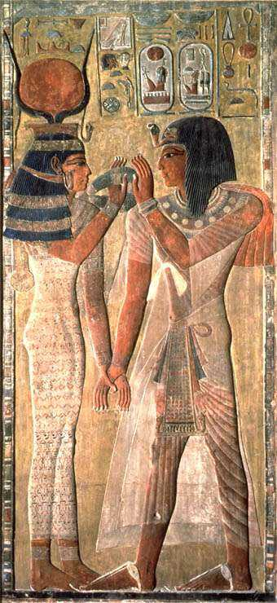
Love Poetry
The Beginning of the Song That Diverts the Heart

(Girl)
How beautiful is your beloved,
the one adored of your heart,
when she has returned from the meadow!
My beloved, my darling,
my heart longs for your love—
all that you created!
I say to you:
See what happened!
I came ready to trap birds,
my snare in one hand,
my cage in the other,
together with my mat.
All the birds of the land Punt
have descended on Egypt,
anointed with myrrh.
The first to come
takes my bait.
Its fragrance comes from Punt,
its claws full of balm.
My heart desires you.
Let us release it together.
I am with you, I alone,
to let you hear the sound of my call,
for my lovely myrrh-anointed one.
You are here with me,
as I set the snare.
Going to the field is pleasant (indeed)
for one who loves it.
[My god, my lotus . . .]

(Girl)
My god, my lotus . . .
The north wind blows . . .
How pleasant it is to go to the river . . .
My heart longs to go down
to bathe before you,
that I may show you my beauty
in a tunic of the finest royal linen,
drenched in fragrant oils,
my hair plaited in reeds.
I ‘d go down to the water with you,
and come out to you carrying a red fish,
which feels just right in my fingers.
I’d set it before you,
while gazing at your beauty.
O my hero, my beloved,
come and see me!

(Boy)
My beloved’s love
is over there, on the other side,
The river surrounds my body.
The flood waters are powerful in the season,
and a crocodile waits on the sandbank.
Yet I went down to the water
To wade through the flood,
my heart brave in the channel.
I found the crocodile to be like a mouse,
And the surface of the water like dry land to my feet.
It is her love
that makes me strong.
She casts a water spell for me!
I see my heart’s beloved
Standing right before me!

(Boy)
My beloved has come,
my heart rejoices,
my arms are open to embrace her.
My heart is as happy in its place
as a fish in its pond.
O night, you are mine forever,
since my lady came to me!

[I wish I were her Nubian Maid]

(Boy)
I wish I were her Nubian maid,
her attendant in secret,
as she brings her a bowl of mandragoras.
It is in her hand,
while she gives pleasure.
In other words:
she would grant me
the hue of her body.

(Boy)
I wish I were the laundryman
of my beloved’s clothes,
for even just a month!
I would be strengthened
by grasping the garments
that touch her body.
For I would be washing out the moringa oils
that are in her kerchief.
Then I’d rub my body
with her castoff garments,
and she . . .
O how would I be in joy and delight,
My body vigorous!

(Boy)
I wish I were her little signet ring,
the keeper of her finger!
I would see her love
each and every day,
And I would steal her heart.

[I passed close by his house]
Sixth Stanza

(Girl)
I passed close by his house,
and found his door ajar.
My beloved was standing beside his mother,
and with him all his brothers and sisters.
Love of him captures the heart
of all who walk along the way—
a precious youth without peer,
a lover excellent of character!
He gazed at me when I passed by,
but I must exult alone.
How joyfully does my heart rejoice, my beloved,
since I first saw you!
If only mother knew my heart
she would go inside for a while.
O Golden One, put that in her heart!
Then I could hurry to my beloved
and kiss him in front of everyone,
and not be ashamed because of anyone.
I would be happy to have them see
that you know me,
and would hold festival to my Goddess.
My heart leaps up to go forth
that I may gaze on my beloved.
How lovely it is to pass by!

[Seven whole days]
Seventh Stanza

(Boy)
Seven whole days I have not seen my beloved.
Illness has invaded me,
my limbs grow heavy,
and I barely sense my own body.
Should the master physicians come to me,
their medicines could not ease my heart.
The lector priests have no good treatment,
because my illness cannot be diagnosed.
But if someone tells me, “Here she is!”—that will revive me.
Her name—that is what will get me up.
The coming and going of her messengers—
that’s what will revive my heart.
More potent than any medicine is my beloved for me;
more powerful than the Physician’s Manual.
Her coming in from outside is my amulet.
If I see her, I’ll become healthy.
If she but gives me a glance, my limbs will regain vigor.
If she speaks, I’ll grow strong.
If I hug her, she’ll drive illness from me.
But she has been gone for seven days.

[Am I not here with you?]

(Girl)
Am I not here with you?
Then why have you set your heart to leave?
Why don’t you embrace me?
Has my deed come back upon me?
If you seek to caress my thighs.
Is it because you are thinking of food
that you would go away?
Or because you are a slave to your belly?
Is it because you care about clothes?
Well, I have a bedsheet!
Is it because you are hungry that you would leave?
Then take my breasts
that their gift may flow forth to you.
Better a day in the embrace of my beloved
than thousands on thousands anywhere else!

